First Program:

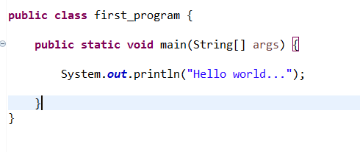

Output:

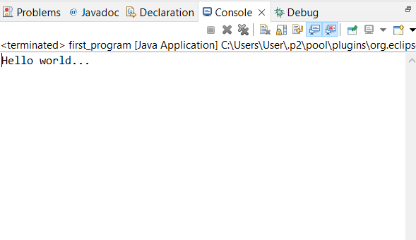

Variables data types literals:

**public** **class** Variables_datatypes_literals {

**public** **static** **void** main(String[] args) {

// Variables:

**int** number=123; // correct way of creating variables

**int** $number1=123;

**int** _number2=123;

**int** number123=123;

**int** number$=123;

**int** my_Number=798933;

**int** 2number=123; // showing compile time error.

**int** number1@=123;

//we cannot use keywords as variable names.

**int** **if**=123;

**int** **for**=123;

**int** **super**=123;

// data types

**byte** b=127; // in byte we can store in range of -128 to -127

**short** s=1234; // in short we can store in range of -32,768 to 32,767

**int** num=123456; // in int we can store in range of -2,147,483,648 to 2,147,483,647

**long** l=123456789; // in long we can store in range of -9,223,372,036,854,775,808 to 9,223,372,036,854,775,807

**float** f=12.3f; // in float we can store only decimal values

**double** d=12.44; // in float we can store decimal values

**boolean** b1=**true**; // in boolean we can store only true or false

**char** c='a'; // in char we can store only single letter

// if we want to store wrong data in different data type

**int** num=1.2; // it will show compile time error 'cannot convect double to int'

**int** n=9223456789; // if we store number that is greater than its range it will show compile time error "out of range error"

**char** c1='ad'; // it will show compiletime error "invalid character constant"

//literals

// in java we have int,float,char,string,boolean

**byte** b2=12; // integer literal

**short** s2=123; // integer literal

**int** i2=123; // integer literal

**long** l=8213713876e12786; // long literal

**float** f2=1.2f; // float literal

**char** c2='a'; // character literal

String s="veera"; // String literal

**boolean** b2=**true**; // boolean literal

}

}